MADOC presents
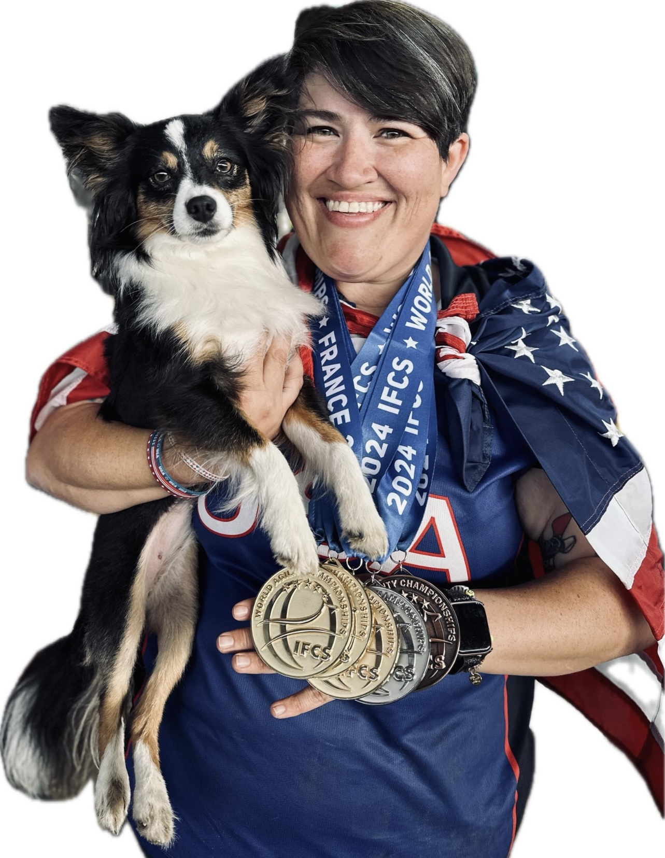
Courtney Moore Agility Seminars May 9 - 10, 2026

Courtney is the Agility Guru at Happy Dog Sports. She has been training dogs for over 25 years. She has taught and competed in most dog sports and in addition to being an avid competitor, she is also a well-known and highly respected judge for both AKC and UKI Agility. She has a deep understanding of how dogs and their humans navigate courses, and she can help each team understand the best handling paths for them. As an instructor she is fun and flexible and can teach within any handling system. Courtney has competed with multiple dogs across all organizations, both in the US and Internationally. Courtney and her dog, Butter, have been members of multiple world teams, 2024 IFCS World Champions, recently had awesome runs at the 2026 National Agility Championship and are headed to 2026 IFCS World Championships in Spain in April.

Seminars are grouped according to the most requested topics. Courtney will set up courses based on participant input from your registration forms, so be sure to write what you want to work on!!

Cost: $150 for working spot, $40 to audit (unlimited auditing spots)

Saturday, May 9, 8 - 11:30am Novice Handling 6 working spots
This seminar is targeted toward dogs and/or handlers competing at the novice level.

Saturday, May 9, 1pm - 4:30pm Distance Handling 6 working spots
Sunday, May 10, 8 - 11:30am Contact Discrimination 6 working spots
Sunday,May 10, 1 - 4:30pm Advanced Handling 6 working spots

